**33. Design DFA using simulator to accept the string having ‘abc’ as substring over the set {a,b,c}**

**AIM:** To design DFA using simulator to accept the string having ‘abc’ as substring over the set {a,b,c}

**TRANSITION DIAGRAM**:

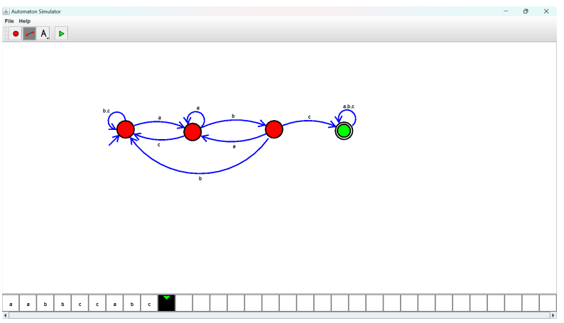

**RESULT:** Hence DFA using simulator to accept the string having abc as substring.